Story of Network Virtualization and its future in Software and Hardware
Anjali Singhai Jain, Alexander H. Duyck, Parthasarathy Sarangam, Nrupal Jani

Intel Inc.
United States
anjali.singhai@intel.com, alexander.h.duyke@intel.com, parthasarathy.sarangam@intel.com, nrupal.jani@intel.com

Abstract
The last several years have seen significant advances in Network Virtualization and its support in Software and in Hardware.
The ongoing evolution of pure software models to become more efficient in terms of fast packet delivery into VMs and the last mile into the application using stack optimization, vHost optimization etc is a work in progress. Pure Hardware solutions that deliver packets straight into a virtual machine, offer the best performance but have had issues of their own. For example: missing control plane to manage the hardware pass through interfaces which are visible only to the virtual machine. These problems did get addressed in software with switch-dev and representor model to control the SRIOV interfaces through the hypervisor, but the list is long.
There have been recent advances in orchestration layers such as Open vSwitch and tc-hooks in the kernel to offload vSwitch flow-caches into the Hardware. This helps to manage SRIOV interfaces through OVS-like orchestration layers and get the best of both worlds when it comes to bare-metal like performance and yet retain a software management of these interfaces and flows. In effect creating a learning switch in the hypervisor and direct packet delivery into the Virtual machines. To get here the Hardware devices had to support flow match rules, access control lists, Tunnel End point packet modifications and much more.
There are still some areas where the Network Virtualization solution can be improved. Areas such as the scalability of Software and Hardware models, east-west traffic within the hypervisor, virtual machine migration, virtual machine compatibility with newer generation of devices, and accelerations on virtualization capable NIC without a change in Virtual machine image. The idea is to take away the rigidness and inflexibility of SRIOV and make it more useful in the cloud, raising the bar on network virtualization.

Keywords
Virtio, virtio-net, SRIOV, vHost, switch-dev, mediated devices, Open vSwitch, xdp, relay driver, IOMMU, SDN, NFV, Intel’s AVF

Introduction
This paper walks through the evolution of Network I/O virtualization on Linux and as the support evolved in Hardware. Most of the historical discussion is to understand the goodness and simplicity of the early models as well as the issues. This walk through will help us build the right model for the future of Network Virtualization. The paper goes into in depth analysis of SRIOV, pros and cons and makes a case for the future model, based on the learnings from our present experience. The future model should retain the goodness that SRIOV brought along, at the same time fix the issues that got introduced. The paper will hypothetically describe the new model where Network Virtualization should be heading. Followed by which it draws a theoretical comparison where the new proposed model should land in terms of performance.

Network Virtualization evolution
When Network Virtualization got started it was all a software model. The easiest way to achieve network virtualization was to use an existing device and driver such as e1000 and emulate the whole device in software so that the VM can use an existing driver and it all just works. An emulated device in the hypervisor recreates the functionality of an actual Hardware device for the virtual machine. When a packet is sent from the VM the emulated device takes a trap and then sends it down the host network stack like a regular packet, the underlying physical function driver handles it just like it would have come from any application running in the host and sends it out on the wire. This is a very simple model and when it started it was a single queue model with a simple implementation. The plus for this model was its simplicity and the fact that a driver already existed and it was supported in almost all OSes. The issues were also due to its simplistic, and as is evident the packet is making a pass through two stacks, one in the Virtual machine and one in the host, not really optimized in Software for performance. The simplicity also meant that it couldn't support much larger line rates.

With all this in mind, para-virtualized model that used a virtio driver came into existence, an interface designed to be optimized in software, supports 64K frames, can support east-west traffic in software backend in the hypervisor. One of the advantages of virtio was one could advertise support for Large receive offload and hand over a really large frame to the virtual machine and the virtio driver knows how to handle that. This wasn't possible in the emulated e1000 model since the hardware device didn't support 64k frames. The downside again in this model is it's still an emulated or a software model where there is a trap/VM exit required to inform the hypervisor that there is a packet to be sent out. Small packet performance suffers greatly because of these traps and memcpy from host to Virtual machine etc. virtio works well for east-west traffic, not so much for north-south traffic where the trap is very visible for every packet and there is no aggregation for those traps as it stands right now.

This led to the third evolution in Network I/O Virtual where one could take a physical interface/port in a 10 gig device such as ixgbe and assign it directly into the VM. This really works well and you get the full 10 gig performance in the Virtual machine. Although the issue here is scalability, once a physical interface is assigned to a VM, number of VMs that can be supported in this direct assign model gets very limited. The other issue is security; say a virtual machine misbehaves and sends invalid frame formations into the hardware, you can bring down the whole device. The model can only work for trusted VMs. If the Virtual machines can't be trusted this model creates huge security vulnerability issues. Denial of services attacks can be very easily crafted from a Virtual machine for other Virtual Machines in this model.

This paved the path for SRIOV for Network Virtualization.

SRIOV: Pros
With SRIOV we get network device level virtualization that helps a lot with scalability and security issues. With SRIOV one gets added security apart from IOMMU level isolation by virtue of function isolation. A device can detect illegal access from the VF interface, inform the PF driver of bad behavior, at which point the PF driver can go ahead and bring the VF interface down without affecting traffic from all other PF and VF interfaces.
We get lot more control plane separation from the PF, one can control the VF features etc from the PF or host plane as compared to direct assign interfaces where all of the control got pulled into the Virtual machine. Once again just like direct assigned interfaces, with SRIOV one gets high packet rate, low latency, and low CPU utilization because of direct assignment of resources such as data path queues, interrupts etc.
There has also been efforts to further get the control plane separation using the switch-dev model for SRIOV capable network virtualization devices. With Switch-dev, one can create VF port representor netdevs in the hypervisor, one per VF, this helps solve 3 issues:
- One can now get VF interface stats, link state visibility etc. in the hypervisor plane.
- One also gets to apply constructs such as programming switch rules for directing traffic to the VF using the representor netdev by using standard netdev-ops , rather than inventing new netdev-ops for the VF interface that apply on the PF netdev using VF id notion which is sort of non-standard.
- It also helps SDN model switches such as OVS to now offload flows into the HW rather than routing it through hypervisor using emulated VF interfaces. This is achieved by exposing slow path learning through VF representor netdev, where OVS running in the hypervisor can learn about the flows and then offload them in the HW to direct them directly to SRIOV backed VF interfaces.

Where did we reach
At this point it’s important to understand why network virtualization as supported in networking hardware needed. It’s also important to understand why getting the Hardware and Software model right so important.
Network virtualization through hardware assist or a complete offload in Hardware is important because this offsets some of the CPU cost in the host machine as compared to a complete software emulated virtual interface model. The CPU cost gets very significant as the number of virtual interfaces running on the host increases, the data rates get higher as well the rules for forwarding the traffic to different virtual interfaces increase. Getting dedicated resources in the Hardware for a virtual interface also has the added benefit of getting QoS properties such a bandwidth rate limiting associated per virtual interface. The virtual machine to wire traffic as is known in the industry by the term north-south traffic gets the best throughput and latency numbers when the packet that leaves the VM goes straight into the hardware or is directly DMAed into the VM from the hardware. So without doubt direct assignment of hardware resources for fast path into a virtual machine or a light weight virtualization schemes such as containers benefit from reducing the CPU footprint and improving throughput and latency number.
But there is a cost, as we will see that a Network hardware device aka NIC starts looking more like a switch device in order to support data pass-through into the right Virtual Interface inside a VM. Most of this happens in the Host in the emulated case but with direct assign a lot of this functionality needs to get implemented in the hardware. Virtual bridges need to be created in the hardware, filtering and redirection needs to happen in the hardware and much more.

Hardware Switch for Virtualization
SRIOV is a PCIE Spec for Device virtualization, when it gets adopted for Network Virtualization it brings along a baggage into the Hardware which has a potential to make the simple NIC device into a full-fledged software managed Switch. A list of features offered by a typical modern Networking device supporting Virtualization is as listed in Figure 1.

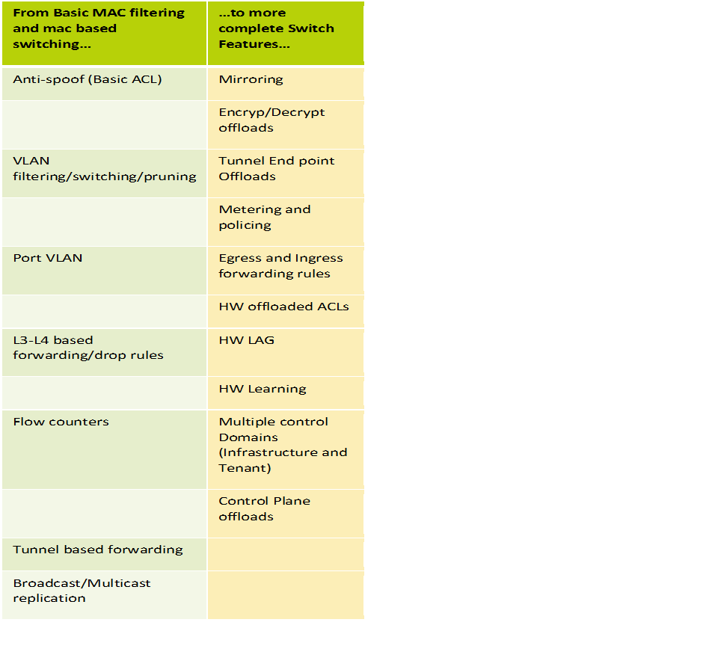
Figure 1. A table capturing typical features supported in an advanced NIC that supports Network Virtualization.
In most cases these features in the NIC are a result of direct pass through for Virtual Interfaces rather than it being the result of SRIOV support, which is a very important distinction to be made. In effect these features are here to stay in a Networking device that allows direct pass through; whether or not SRIOV stays is a point of discussion.

SRIOV: Cons
SRIOV is an easy model to expose Network Virtualization if one was to assume that the VMs where pretty homogenous and that they lived for a reasonable amount of time. Current virtualization trends where VMs are very light weight like containers and are non-homogenous, SRIOV could use some transformations. It is too rigid, non-compose-able and too much resource drain on the device and PCIE config space etc. as it turns out.
With VMDq supported acceleration, the Virtual function driver was still left agnostic of the Hardware resources that were used for acceleration. But with SRIOV came along the whole PCI config space of the device as defined in the HW, which resulted in many vendor and device specific drivers for the virtual function. A step that seems to have gone a little too intrusive.
Although with SRIOV, there was some separation of data plane and control plane, usually a device has to offer some kind of a hardware mailbox to communicate between the PF and VF device. Yet another of the features that needed to be provided by the device, because of a complete pass through of the device in a VM. Most of the PCI-E config space is a direct pass through from the Hardware into the VM which creates unnecessary bloat in the Host PCI-E config space. The SRIOV PCI-E devices clobber up space on the Host, an unnecessary feature in some cases.

Future and In Progress Enhancements

Adaptive Virtual Function Driver
The idea of Adaptive Virtual Function driver stems from the fact that high quality connectivity in a Virtual Machine should be a basic ingredient not an update irrespective of the HW underneath. As mentioned earlier Para virtualized model that helped create basic connectivity in the VM in software has the goodness of it always being there irrespective of what the physical device underneath happens to be although it doesn’t provide high speed north-south connectivity plus the fact that it adds a CPU footprint which is the biggest plus point for SRIOV/pass through devices. If a virtio like software model can be created for the pass through devices that can directly do DMA into the hardware without having to get an updated or new driver every time the device changed would be the ideal scenario. With that in mind Intel’s AVF driver got introduced. Although this is still vendor specific solution, it still promises the basic high speed connectivity for all future Intel devices without requiring a VM update. And since this happens to be an adaptive VF driver, every new drop of the VF driver would add more and more advanced features that can be turned on in the VM if the underlying HW device supports those advanced features. Most importantly in a device agnostic way without ever compromising on the base functionality.
The ideal scenario would have been a pass through VM driver that is common across vendors that could also negotiate extended capabilities based on the HW underneath.

Live Migration with SRIOV
As it stands now there is no good way of doing live migration of a VM using true SRIOV device pass-through interface for its connectivity in Linux.
One software based solution is to make the VM driver aware of migration and change the VM driver model to accommodate for two sets of queues, one that is direct pass through and the other that is backed by emulated backend queues that are used as the fallback queues during migration. This solution although simple is not transparent to the VF driver and requires some re-designing of the driver. But this solution could scale well for heterogeneous clouds where the HW underneath between the two machines could be completely different.
For a true SRIOV solution without a VM driver change as an option, one would need either changes in platform design or some more state keeping in the NIC to make this possible. In the platform change model, the IOMMU would need updating to keep track of dirty pages both in case of pages dirtied by the host and by the devices, so that they can be marked as such while live migrating and states can be transferred across the machines. Even then it would only be possible to achieve that in a homogeneous cloud where the VM being migrated from one machine to another would be using an SRIOV interface that is compatible in terms of Network Hardware between the two devices. Both these solutions are far from being available because they require HW changes.

Para Virtualized solution with HW Acceleration
A true device pass through of an SRIOV device as mentioned earlier creates challenges such as live migration, very rigid VFs and PCI-E config space clobbering in the Host. When the number of Network Virtualized interfaces on a single hypervisor start running into thousands, one has to come up with a light weight version of pass through that may not require a complete PCI-E device pass-through but just the right amount of pass-through to facilitate the hot-path activities.

Composable VFs
A model that works best in the future would have to retain the goodness of SRIOV yet do away with its issues. Things we must achieve
- Single VF driver model at least per vendor that becomes feature rich as the devices evolve.
- Still retain all the security and memory isolation goodness provided by SRIOV.
- Pass through of North-south fast path to get the CPU utilization and throughput numbers of SRIOV.
- An option to fall back to an emulated backend queues to help facilitate live migration.
- An option to either have East-West traffic handled in SW or pass through whichever makes better sense for a use case.
- The control path for VF interface configuration could be in software or in hardware depending on use case.
- An option to have no PCIE footprint for Virtualized devices on Host PCI bus if not desired.
- Asymmetric and runtime distribution of hardware resources among the Virtual interfaces and dynamic mapping of Virtualized interfaces and their flows to external interfaces for a given device.
- Composability, configuration and flow programming for the Virtual Interfaces completely visible in the Host plane through standard netdev-ops in device-agnostic manner.
- May be extend the scalability of SRIOV interfaces beyond what is provided through PCIE spec.

Conclusion

To conclude, high throughput, low CPU utilization through Hardware Network virtualization is absolutely desired. SRIOV direct device pass-through was a good first step but we can do better than that in Hardware and in Software. Lot of the desired features of a Composable Virtual function as listed earlier can be achieved by changes in the Software model. Instead of doing a complete device pass through of an SRIOV interface one creates a composed backend device that takes benefit of an SRIOV interface while solving the SRIOV issues using clever software composing of the backend device with just the right ingredients that are pass-through and the rest that are not. This would help create a light-weight version of SRIOV. Some of the scalability and PCI-E config space bloat issues can only be solved through Hardware innovation. Figure 2 illustrates the composed VF interface model that runs on a composed backend device in the Hypervisor.
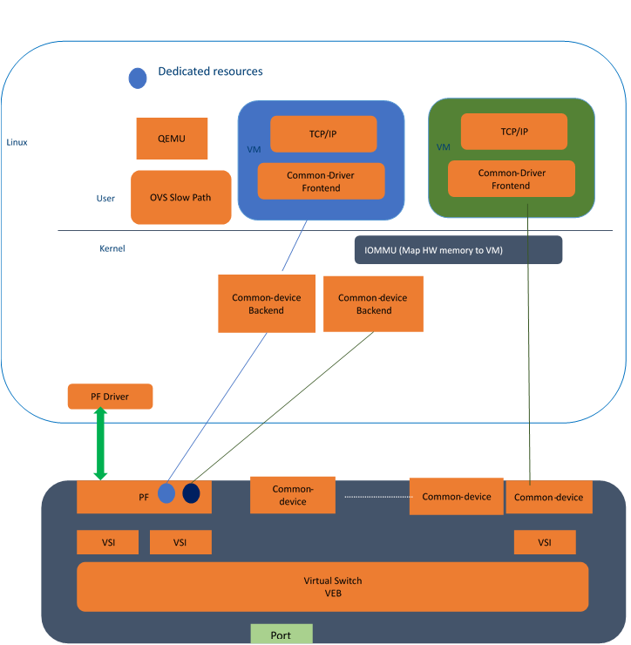
Figure 2. Para virtualized Model with HW Acceleration, the figure shows the left model with green VM as a complete pass through, whereas the Blue VM gets a composed Network device with some pass through and some emulated resources.

References
Websites
1. Netronome XVIO solution https://www.netronome.com/media/redactor_files/TB_XVIO.pdf
2. Intel’s recent whitepaper on SRIOV and NFV performance http://www.intel.com/content/dam/www/public/us/en/documents/technology-briefs/sr-iov-nfv-tech-brief.pdf
3. Mediated devices for graphics
https://github.com/torvalds/linux/blob/master/Documentation/vfio-mediated-device.txt
Proceedings Paper Published
4. PCISIG IOV Specifications
https://pcisig.com/specifications/iov/
5. Intel AVF driver
https://netdevconf.org/1.2/slides/oct6/05_Single_Virtual_function_driver_for_current_and_future.pdf

Authors Biographies
Anjali Singhai Jain is a Software Architect at Intel’s Networking Division. Having worked exclusively in Networking for past 13 years at Intel, she has seen and contributed towards many generations of Network software Architecture, software implementation and design of Network Hardware devices. Currently she focuses her work at Intel in defining next generation silicon features and software programming models.

Alexander Duyck is an Open Source Technologist at Intel. He has worked on Linux and kernel networking over the last 10 years contributing to many areas of kernel networking including drivers such as igb, igbvf, and fm10k, features such as DCB and SR-IOV, routing, general driver performance, and tunnel offloads.

Parthasarathy Sarangam is a Senior Principal Engineer in the Intel’s Networking Division and lead architect for many of the Intel’s 10G and 40G Ethernet controllers. He has many years of experience in defining Ethernet controller’s SW interface, I/O virtualization and virtual Ethernet bridges.

Nrupal Jani works in the Intel Networking Division as a Software Architect. He currently works on the various NIC IO Virtualization technologies such as SR-IOV, VMDq. He currently also works with the OS vendors to enable the HW features in the OS/Hypervisors.

